Git and github-01
Git-is a version control system used to track changes in your code
It helps you save your work ,track history, and go back to previous version anytime.
GitHub - is a central repository system used for source code management system
cloud platform that stores you git repositories online
It is a website where you upload your git projects and collaborate with others.
Git - version - we can check the version
Git - init - is used to initialize a new repository in your project folder
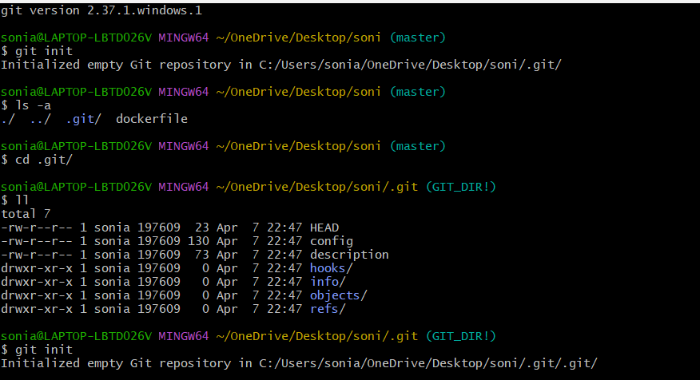
Cd .. - one step back
Git status - to check the status our repository

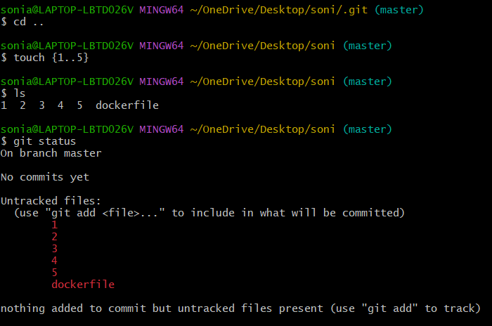
Git config -list :it will help us to get all the details like userdetails .username.and defult details
To configure git first I have added username and email
- Git config --global user.name “sonia”
- Git config --global user.email “soniaddabottu@gmail.com
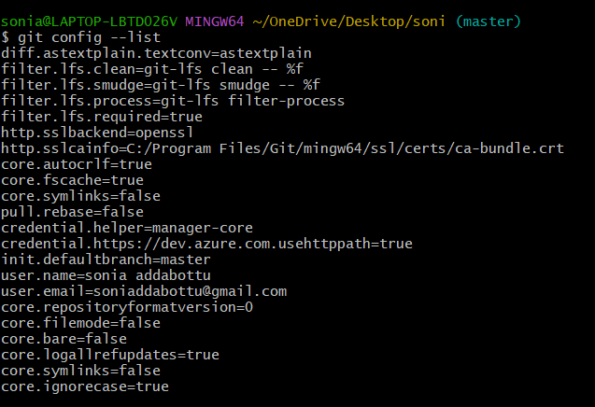
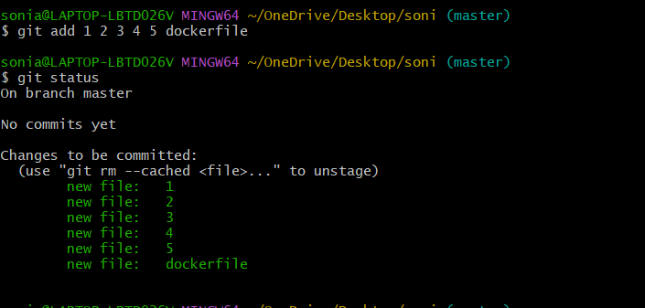
To add multiple files to traking are we use
Git add .
git status – To check the status of our repository like what changes we have made and how many files are added.
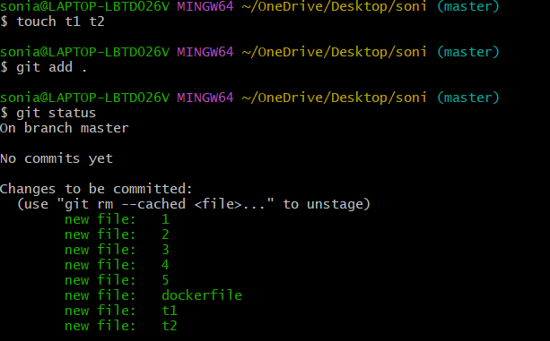

Git commit -m “added couple of files” – Changes made will be tracked or committed
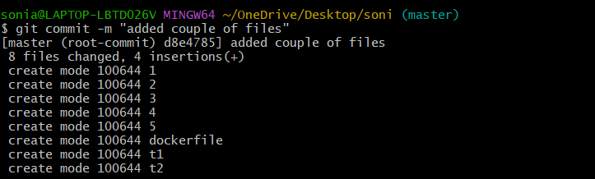
git log – It prints all the logs
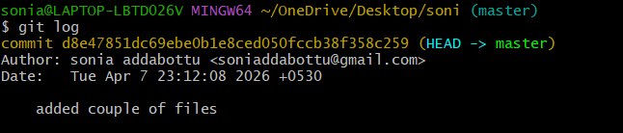
git push – To move all the changes to be stored in central repository
git remote -v - We can check if any addresses has been configured or not
git remote origin URL – It will add the destination
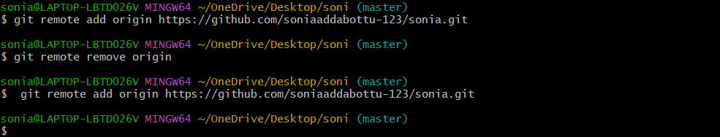
Ssh-keygen – To generate a ssh key
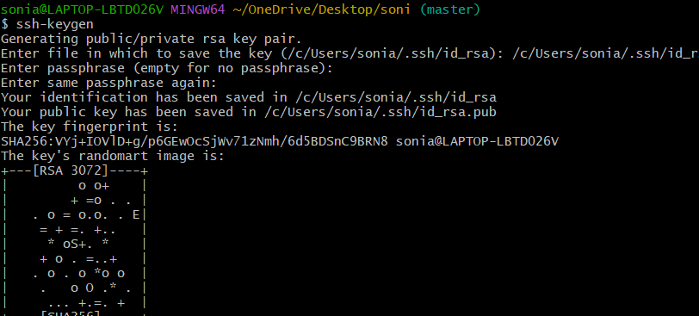
Before pushing we need to have the connectivity from machine to repository. I have added key gen.
Click on settings select ssh and gpg key click on new ssh keyadd title Add keygen
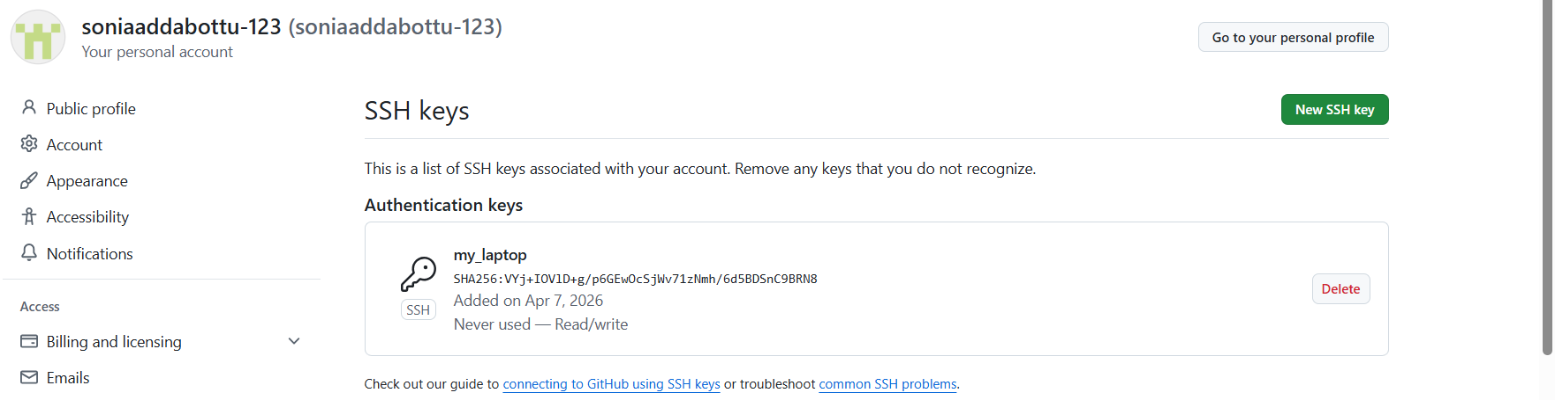
Git push -u
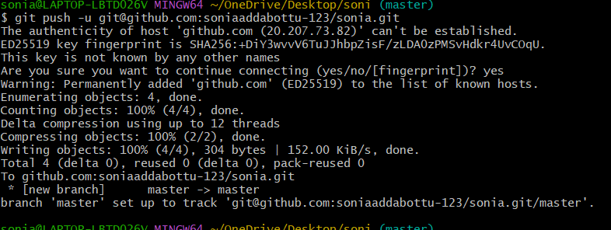
Git pull
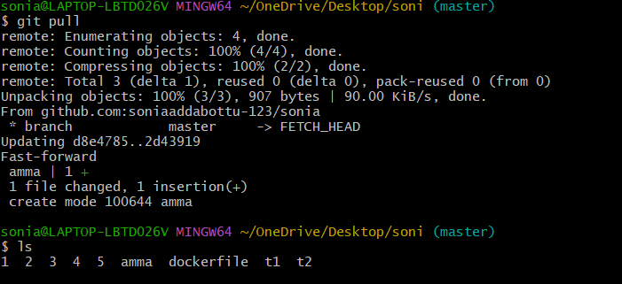
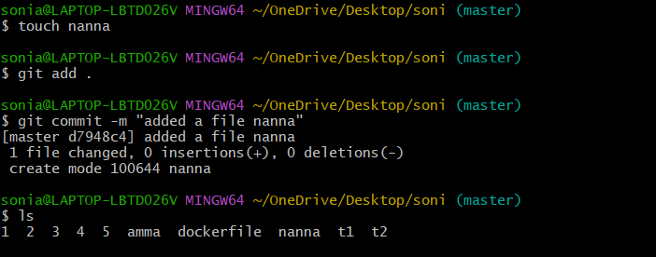
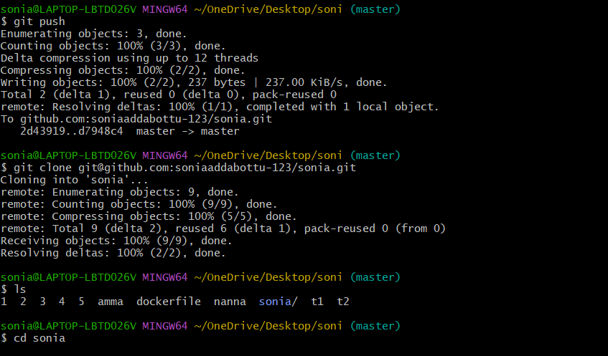

We can remove the one file
Rm dockerfile
